
YEAR 12 Essentials Mathematics
Semester 2 2021
Longitude/Latitude & Time Zones

Name: ______________________ Mark: ______ / 31 marks

Full working out must be shown to get full marks.

Attempt all questions

Resources allowed:

1 A4 page, (1 side) of hand written notes, ruler, calculator

- Use the map of the world to answer the following questions: (4 marks)
B
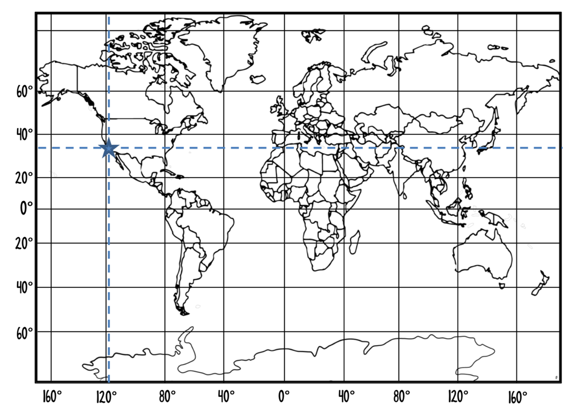
A

- Name the significant line labeled A.__________________________________

- Name the significant line labeled B.________________________________

- Los Angeles is located on the map with a triangle. What are the coordinates of Los Angeles? ____________________________________________

- South Africa is located on the map with a circle. What are the approximate coordinates of South Africa? ____________________________________________

- Calculate the arc length (shown in bold) in the following circles (Answer in cm) (5 marks)
- (b)
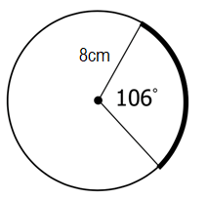 | 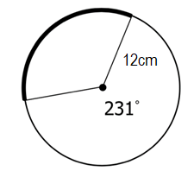

- Find the arc angle between Bali (5°S, 115°E) and Mandurah (35°S, 115°E) correct to the nearest degree. (1 Mark)

- A (23°N, 121°W) and B (65°N, 121°W) are two points on the surface of the Earth. Find the distance to the nearest kilometer between the points A and B.
(Approximate the radius of the Earth as 6 400km) (3 Marks)

- Find the distance between Stockholm (59°N 18° E) and Cape Town (34°S 18°E) correct to the nearest kilometer.
(Approximate the radius of the Earth as 6 400 km) (3 Marks)

- Using the Time Zones table below answer the following questions (4 Marks)

City | Time
Sydney | GMT+10
Melbourne | GMT+10
Adelaide | GMT+9:30
Perth | GMT+8
Darwin | GMT+9:30
Brisbane | GMT+10
Hobart | GMT+10

  - If it is 3: 51 PM in Sydney, what time would it be in Darwin?

  - If it is 11:45 pm in Perth, what time would it be in Melbourne (considering daylight savings is in effect)?

- Han, who is in Canberra (GMT +10) at the moment, has an interview over Skype with the human resources manager of an American trading firm scheduled for 3 pm on Monday, New York (GMT -5) time. (3 Marks)

- Calculate the time difference between the two cities.

- Find the time in Canberra when it is 3pm on Monday in New York.

- What day will the interview fall on in Canberra?

- An aircraft travels at an average speed of 913 km/h. It departs from a town in Kenya (0°, 38° E) on Tuesday at 10 pm and flies east to Borneo (0°, 113° E). (8 marks)

  - What is the distance, to the nearest kilometre, between the two towns? (Assume the radius of the earth is 6400km)

  - How long will the flight take? (Answer to the nearest hour)

  - What will be the local time in Borneo when the aircraft arrives? (NOTE: Kenya is GMT+3 and Borneo is GMT+8)

END OF TEST

